INTRODUCTION:
A retaining wall is a masonry or concrete wall which gives lateral support to earth. Concrete retaining walls provide a durable solution that is required of a structure in contact with soil and exposed to constant wetting and drying. Concrete does not rot and is resistant to termites. Retaining walls are structures that support backfill and allow for a change of grade. For instance a retaining wall can be used to retain fill along a slope or it can be used to support a cut into a slope as shown in figure 1.
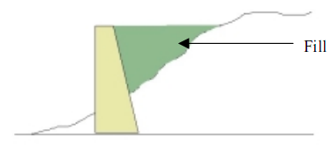
Retaining wall to support a fill
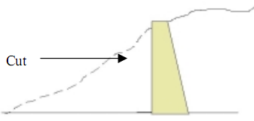
Retaining wall to support a Cut.
The wide range of available options ensures that a suitable solution can be found for any situation. Retaining walls are designed to resist earth pressures exerted by only the weight of soil retained. These are much less than the hydrostatic pressure exerted by water trapped behind the wall.
There are three categories of lateral earth pressure and each depends upon the movement experienced by the vertical wall on which the pressure is acting as shown in figure 2.
1. At rest earth pressure
2. Active earth pressure
3. Passive earth pressure
At rest earth pressure:
The at rest pressure develops when the wall experiences no lateral movement.
Active earth pressure:
If the wall deforms away from the retaining earth due to the earth pressure it is called active earth pressure.
Passive earth pressure:
If the wall deforms towards the retaining earth it is called passive earth pressure.
Angle of repose: (Φ)
The max inclination of the soil plane with horizontal at which the soil remains in equilibrium by friction is called angle of repose.
For water the angle of repose is zero.
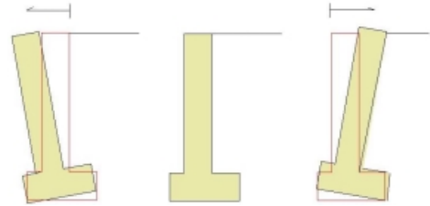
Active Case At Rest Case Passive Case
(Wall moves away from soil) (No movement) (Wall moves into soil)
Figure 2: Wall Movement

TYPES OF RETAINING WALLS
Retaining walls can be grouped into three distinct categories by considering the way in which they resist the lateral pressure exerted by the soil and any surcharge.
Gravity retaining walls
These walls use their own weight and any captured soil/fill weight to resist the lateral soil pressure figure 1.
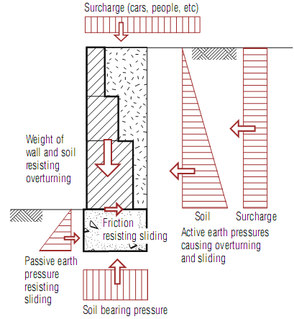
Figure 3: gravity retaining wall
Gravity Retaining walls (Fig 1) are the oldest and simplest type of retaining walls. The gravity wall retaining walls are thick and stiff enough that they do not bend; their movement occurs essentially by rigid body translation and or by rotation.

Piled retaining walls
These walls use the embedded depth of vertical posts and the strength of the posts to resist lateral soil forces figure 2.
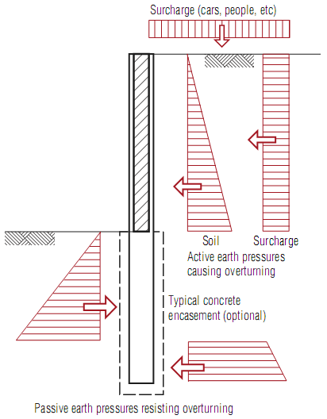
Figure 4: Piled retaining wall

Cantilever retaining walls
These walls cantilever vertically from the concrete footing and typically resist overturning by the mass of the soil/material on the heel of the footing figure 3.
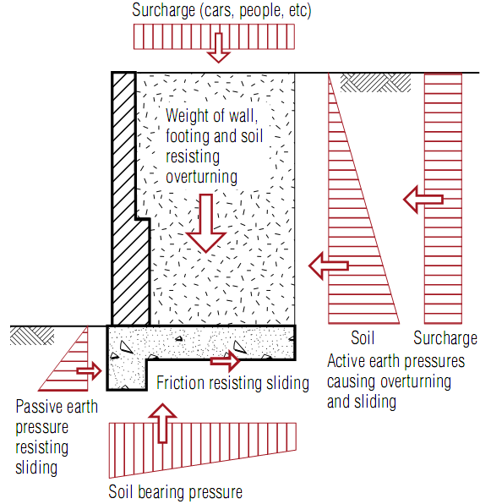
Figure 5: Cantilever retaining wall
The cantilever retaining wall as shown in Fig.1b bends as well as translates and rotates. They rely on the flexural strength to resist lateral earth pressures. The actual distribution of lateral earth pressure on a cantilever wall is influenced by the relative stiffness and deformation both the wall and the soil.
In above all walls might be constructed from materials such as filed stone, reinforced concrete , gabions, reinforced earth, steel and timber. Each of these walls must be designed to resist the external forces applied to the wall from earth pressure, surcharge, surcharge load, water, earthquake etc.
Within these three categories a number of different and innovative concrete retaining wall types are available.
STATIC PRESSURE ON RETAINING WALL
When discussing active and passive lateral earth pressure, there are two relatively simple classical theories (among others) that are widely used.
1. Rankine Earth Pressure Theory
2. Coulomb Earth Pressure Theory
Calculation of Static Earth Pressure: Rankine Theory
Rankine’s theory of earth pressure:
Assumptions made in rankine theory of earth pressure
- The soil consists of noncohesive granular soil particles
- The friction between the face of the wall and soil is neglected and the earth retaining face is vertical
- The failure of the soil mass occurs along the plane of rupture.
Rankine (1857) developed the simplest procedure for computing the minimum active and maximum passive earth pressure. For minimum active condition, Rankine expressed the pressure at a point on the back of a retaining wall as
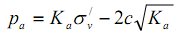
Where K_{a} is the coefficient of minimum active earth pressure, 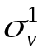 is the vertical effective stress at the point of interest, and c is the cohesive strength of the soil. When the principal stress planes are vertical and horizontal (as in case of a smooth vertical wall retaining a horizontal backfill), the minimum active pressure coefficient is given by the equation:
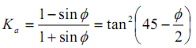
For the case of the cohesionless backfill inclined at angle β with the horizontal infinite slope solution can be used to compute K_{a} as:
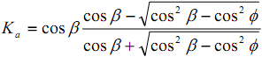
The Rankine theory predicts triangular active pressure distribution oriented parallel to the backfill surface for homogeneous cohesionless backfill. The resultant active earth pressure P_{A} acts at a point located at height H/3 above the base of the wall height with the magnitude:
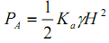
For smooth, vertical walls retaining horizontal backfills K_{p} is calculated from the relation;
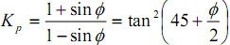
and for backfill inclined at β to horizontal
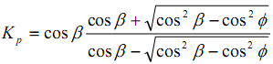
For homogeneous dry backfill Rankine theory predicts a triangular distribution oriented parallel to the backfill surface. The backfill earth pressure resultant, or the passive thrust P_{p} , acts at a point located at H/3 above the base a wall of height H with the magnitude;
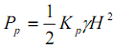
CALCULATION OF STATIC EARTH PRESSURE: COULOMB THEORY
By assuming that the forces acting on the back of the retaining wall resulted from the weight of the wedge of the soil above a planar failure plane surface coulomb used force equilibrium to determine the magnitude of the thrust acting on the wall for both minimum active and maximum passive conditions. Active thrust on wall retaining a cohesionless soil can be expressed as
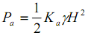
where,
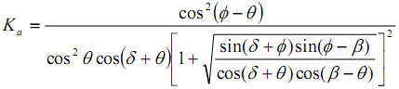
δ is the angle of wall friction between the wall and the soil, β is the angle of slope of filling and θ is the angle of inner face of wall with the vertical face.
Coulomb theory does not explicitly predict the distribution of active pressure, but it can be shown to be triangular for linear backfill surface with no loads. In such case, P_{a} acts at a point located at H/3 above the height of wall of height H.
Retaining Wall Design: Proportioning
1) First, approximate dimensions are chosen for the retaining wall.
2) First, approximate dimensions are chosen for these dimensions.
3) Section is changed if it’s undesirable from the stability or economy point of view.
Stability of retaining wall
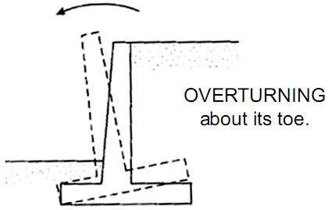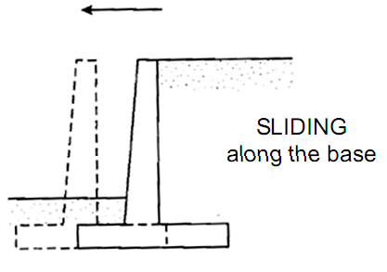
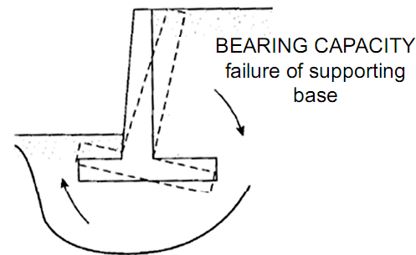

The following parameters influence the design of the retaining wall:
- Wall height
- Soil type
- Sloping land below and/or above the retaining wall
- Loads above and behind the retaining wall, eg parked cars.
Soil restrained by a vertical or near-vertical retaining wall exerts a lateral pressure against the wall. This pressure tends to cause sliding and /or rotation of the wall which must therefore be designed to resist these forces over the intended design life. Apart from structural design, durability and drainage must also be given particular attention.

Stability of the wall
- Stability against sliding:

Factor of safety against sliding
The factor of safety against sliding not less than 1.5.
For no sliding to take place
µ = coefficient of friction between the base and soil
W = total vertical load
P = horizontal earth pressure
- Overturning:
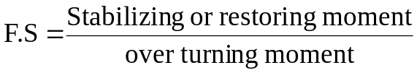
Over turning moments = 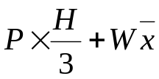
Stabilizing moment = W.Z
Factor of safety against over turning 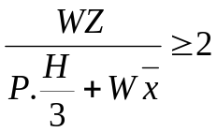
The factor of safety against over turning should not be less than 2.
3. No tension to occur at the base
(a) The condition for no tension to occur at the base is; the resultant thrust should strike the base with the middle third (b/3)
i.e., 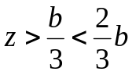
(b) The resultant should strike the base with in a distance of b/6 from the centre of the base on either side when the dam is empty or full.
(c) The eccentricity of the resultant thrust
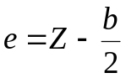
Where, Z = the distance where the resultant strikes the base from the vertical face of the wall.
The maximum and minimum pressures at the base
The stress or pressure at the base occur due to
1. Direct load W
2. Bending moment W x e
3. The max compressive pressure occurs at the toe
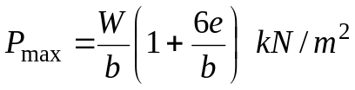Compressive
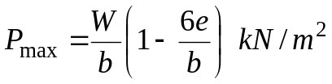 Compressive
Note: if in the above equation 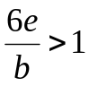tension occurs at the base.
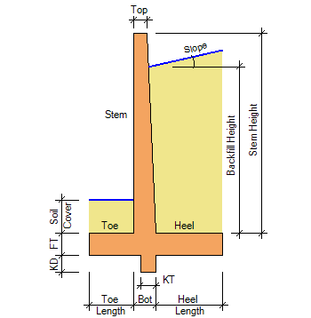
Active & Passive earth pressure calculations:

Stability checks
 | Calculated FOS
Sliding safety factor |  | >1.5
Overturning safety factor |  | >2.0
Maximum Base pressure
Minimum Base pressure

QUIZ:
- The earth retained by retaining wall called?
- Surcharge
- Angle of repose
- Back fill
- None
- The earth retained above the top of retaining wall called?
- Surcharge
- Angle of repose
- Back fill
- None
- If the angle of repose increases, the co-efficient of active earth pressure
  - Increases
  - Decreases
  - No change
  - None
- The shape of the stress distribution diagram for a retaining wall with surcharge is
- Triangle
- Rectangle
- Trapezium
- Parabola
- The factor of safety for overturning is
- 1.5
- 2
- 2.5
- 3

PART – 2
ANIMATION STEPS
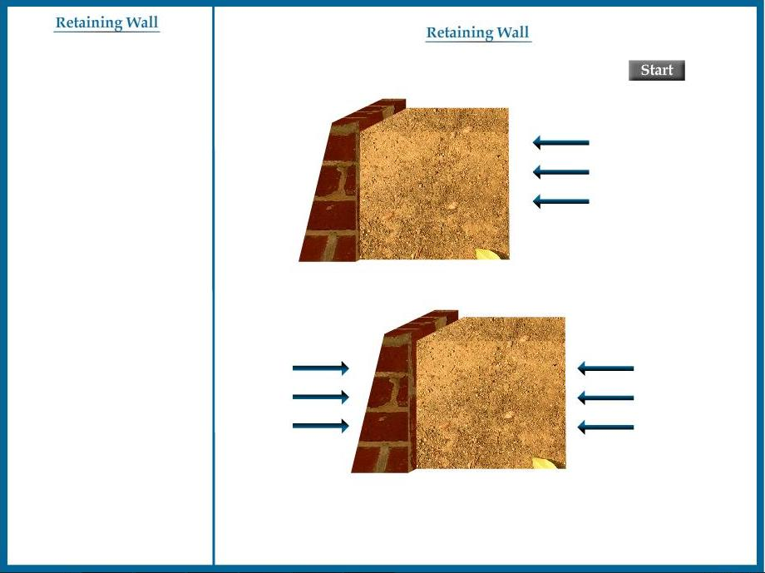

PART – 3
VIRTUAL LAB FRAME

